**AIM:**

**To implement merge sort in C to sort a list of elements in ascending order.**

**📌 ALGORITHM: *(Merge Sort)***

1. Divide the array into two halves recursively until each sub-array has one element.
2. Merge the sub-arrays in a sorted manner.
3. Repeat merging until the full array is sorted.

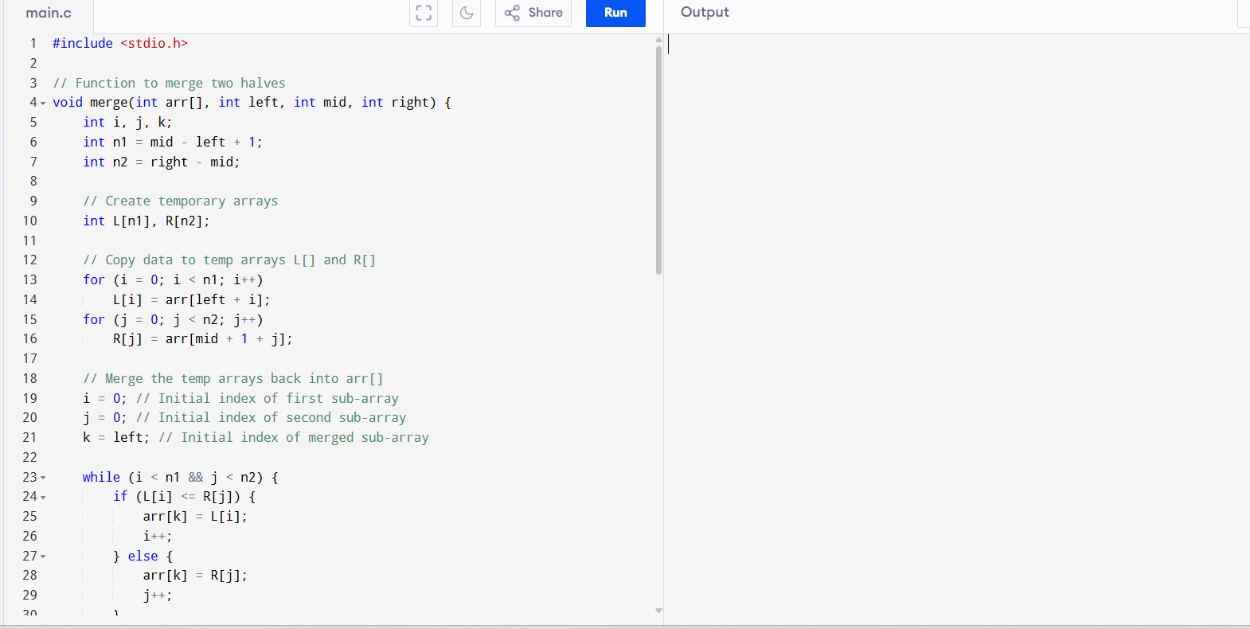

**SAMPLE OUTPUT:**

Enter number of elements: 6

Enter 6 elements:

45 23 67 12 89 34

Original array:

45 23 67 12 89 34

Sorted array using Merge Sort:

12 23 34 45 67 89